

DATE

Mr. and Mrs, XXXX
Address
Address

Thank you for becoming a Sponsor of the Hillsborough Auxiliary to Peninsula Family Service 2016 Gala: Black Tie & Boots. Your donation helps Peninsula Family Service continue to serve its mission of strengthening the community by providing children, families and older adults the support and tools to realize their full potential and lead healthy, stable lives.

Please find an attached receipt for your 2015 donation. Another tax letter and receipt will be mailed after the gala for 2016.

The Hillsborough Auxiliary to Peninsula Family Service is proud to partner with you and looks forward to a great evening at Menlo Circus Club on April 9th!

Best,

The Gala Gals


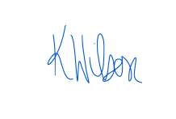


Agapi Burkard, Jennifer Buckley, Katharine Wilson & Megan Winters



